EXP NO 6

Simulate the lifecycle stages for UI design using the RAD model and develop a small interactive interface using Axure RP

AIM:
The aim is to demonstrate the lifecycle stages of UI design through the RAD (Rapid Application Development) model and develop a small interactive grocery shopping interface using Figma as the prototyping tool.
The Rapid Application Development (RAD) model in User Interface
Design emphasizes speed and adaptability by focusing on building quick,
interactive prototypes. Rather than spending extensive time on initial
documentation, RAD encourages early design mockups that can be
refined through continuous feedback from users. This iterative, user
focused method helps catch usability issues early on, ensures the interface
evolves with user needs, and significantly reduces the time between
design and deployment.

PROCEDURE:
=> Phase 1: Requirements Planning(Identify Key Features, Create a Requirements
Document)
=> Phase 2: User Design (Display The Wireframe)
=> Phase 3: Construction (Test and Iterate)
=> Phase 4: Cutover(Finalize and Export)
Phase 1: Identify the Requirements
- Login / Signup Page
(Allow users to create an account or sign in.)
Home Page with Featured Categories
(Display main categories like Vegetables, Fruits, Dairy, Staples.)
- Search Functionality
(Allow users to search for specific grocery items.)
- Category Listing Pages
(Show list of products under each category.)
- Product Details Page
(Display product name, price, image, quantity selector, and Add to Cart
button.)
- Cart Page
(View selected items, edit quantity, remove items, view total price.)
- Checkout Page
(Collect delivery address and payment method, confirm order.)
- Order Confirmation Page
(Display thank you message with order summary.)
- Profile Management
(Update address, contact information, view profile.)
Requirements Document:

Objective:

The objective of this grocery shopping app UI design is to create a simple, intuitive, and
seamless platform where users can easily browse, search, and purchase groceries online.
The app should allow users to log in or sign up, explore various product categories, view
detailed product information, manage a shopping cart, complete checkout with delivery
details, and view their order history. The design must focus on ease of use, quick
navigation, and a delightful shopping experience, ensuring accessibility across all types of
devices and catering to users of all age groups.

How to Measure

The success of the UI design will be evaluated through key usability and performance
metrics. These include the user task completion rate, which measures how easily users can
add items to the cart and place orders without confusion. Time on task will be tracked to
assess the efficiency of finding and purchasing products. User satisfaction will be gauged
through feedback sessions and usability surveys. Error rates, such as incorrect item
selection or abandoned carts, will help identify potential pain points. Retention rate will
measure how often users return to reorder groceries, indicating the effectiveness of the
overall experience.

Who Are the Users

The primary users of the app are everyday shoppers seeking convenience in purchasing
fresh groceries, fruits, vegetables, dairy products, and household staples. Secondary users
may include busy professionals, elderly users who prefer home delivery, and small
businesses that require bulk grocery orders. The app must cater to varying levels of tech
savviness, ensuring that navigation, cart management, and checkout processes are easy for
all types of users. Additionally, delivery partners and admin users might access limited
modules for order fulfillment and inventory management.

Product Flow

The user journey begins with a simple and secure login or signup process using mobile
number, email, or social login options. Upon logging in, users are directed to the Home
Page featuring a search bar, promotional banners, and popular grocery categories. Users
can browse through categories like Fruits, Vegetables, Dairy, Staples, and Snacks, or
directly search for specific products.

Selecting a product opens a detailed page with product image, price per quantity,
description, and an "Add to Cart" button. Users can view their cart, adjust quantities,
remove items, and view the running total.

During checkout, users enter their delivery address and select a payment method (e.g.,
Cash on Delivery). After placing an order, an Order Confirmation page summarizes the
purchase with an estimated delivery time.

Users can track their past purchases through the Order History section and manage their
profiles by updating personal details like delivery addresses or contact numbers. The
design prioritizes quick loading times, a clean visual hierarchy, and a mobile-friendly
responsive layout to ensure a smooth grocery shopping experience.

User Stories and Use Cases:

User Story 1:
As a registered user, I want to log in securely so I can start shopping for groceries.
Use Case:
The user enters their mobile number and password (or uses social login), successfully
authenticates, and is redirected to the home page displaying categories and featured
products.

User Story 2:
As a user, I want to browse grocery categories easily so I can find the items I need.
Use Case:
From the home screen, the user selects a category such as "Vegetables" or "Dairy" to
view the list of available products under that section.

User Story 3:
As a user, I want to add multiple products to my cart quickly so I can complete my
shopping efficiently.
Use Case:
On the product listing page, the user taps on "Add to Cart" for each product they want to
buy. A cart counter updates dynamically as products are added.

User Story 4:
As a user, I want to view and edit my cart before checking out to ensure my order is
correct.
Use Case:
The user navigates to the Cart page, where they can increase or decrease product
quantities, remove unwanted items, and view the updated total bill before proceeding to
checkout.

User Story 5:
As a user, I want to complete my purchase by providing delivery details and choosing a
payment method.
Use Case:
During checkout, the user fills in delivery address details, reviews the final order, selects
"Cash on Delivery," and places the order.

User Story 6:
As a user, I want to track my previous grocery orders so I can reorder quickly if needed.
Use Case:
The user visits the "Order History" section from the profile menu to view past orders,
their statuses, and reorder items if required.

Phase 2: User Design
Create The Wireframes:

Login page:

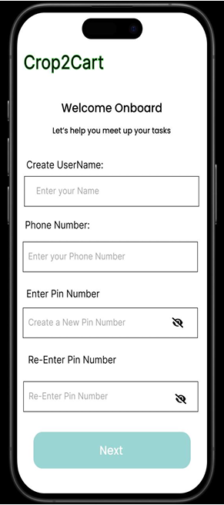

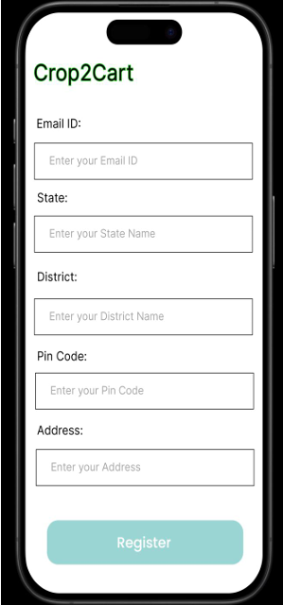

Categories Page
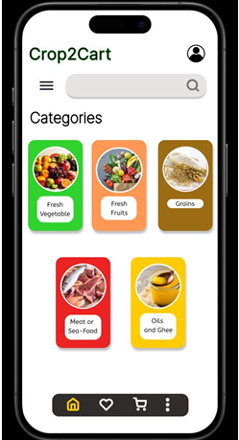
-Product Detail Page
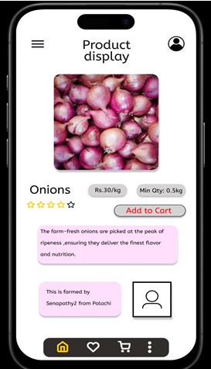
Checkout Page

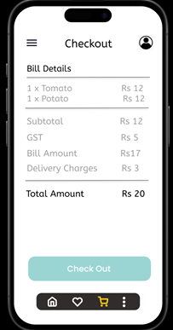

Payment Page
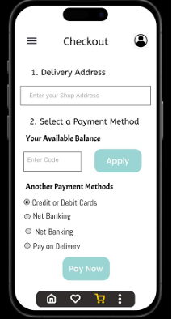
Phase 3: Construction (Test and Iterate)
Test (n Times):
In this phase, the grocery shopping app design was reviewed and tested
multiple times by a small group of users and stakeholders. Each testing round
involved exploring the current UI and suggesting improvements or missing
elements. Based on the feedback, iterations were carried out to enhance
usability, add missing functionality, and improve the overall user experience.
Each round focused on a specific improvement before retesting the updated
version.

Iteration 1:
→ User Feedback:
Users requested the ability to view and manage their profile details after
logging in.
→ Action Taken:
A dedicated Profile Management Page was added. Users can now update
their name, delivery address, and contact number through a clean, accessible
interface.

Iteration 2:
→ User Feedback:
There was no way to view selected items before checkout. Users needed an
overview page to review and manage cart items.
→ Action Taken:
A fully functional Cart Page was designed and added. It allows users to
review products, change quantities, remove items, and view the total bill
before placing an order.

Iteration 3:
→ User Feedback:
After placing an order, users wanted confirmation that the process was
successful along with basic details like order ID and estimated delivery.
→ Action Taken:
An Order Confirmation Page was introduced. It displays a thank you
message, summary of the order, and a "Continue Shopping" button to return to
the Home Page.

Phase 4: Cutover(Finalize and Export)
Finalized Design:

Cart page: Delivery address page
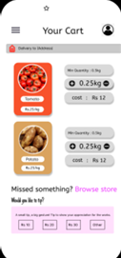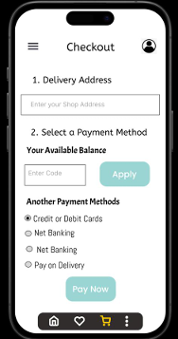

Order placement

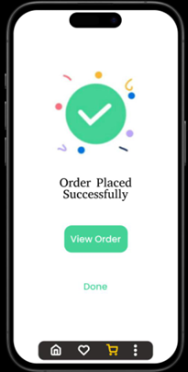
This project effectively demonstrated the complete UI design lifecycle using the Rapid Application Development (RAD) model, from planning to deployment. By leveraging Axure RP, we rapidly created, tested, and refined interactive prototypes based on user feedback. The structured RAD approach enabled faster iterations, improved user involvement, and resulted in a user-friendly, functional interface ready for deployment and real-world use.

